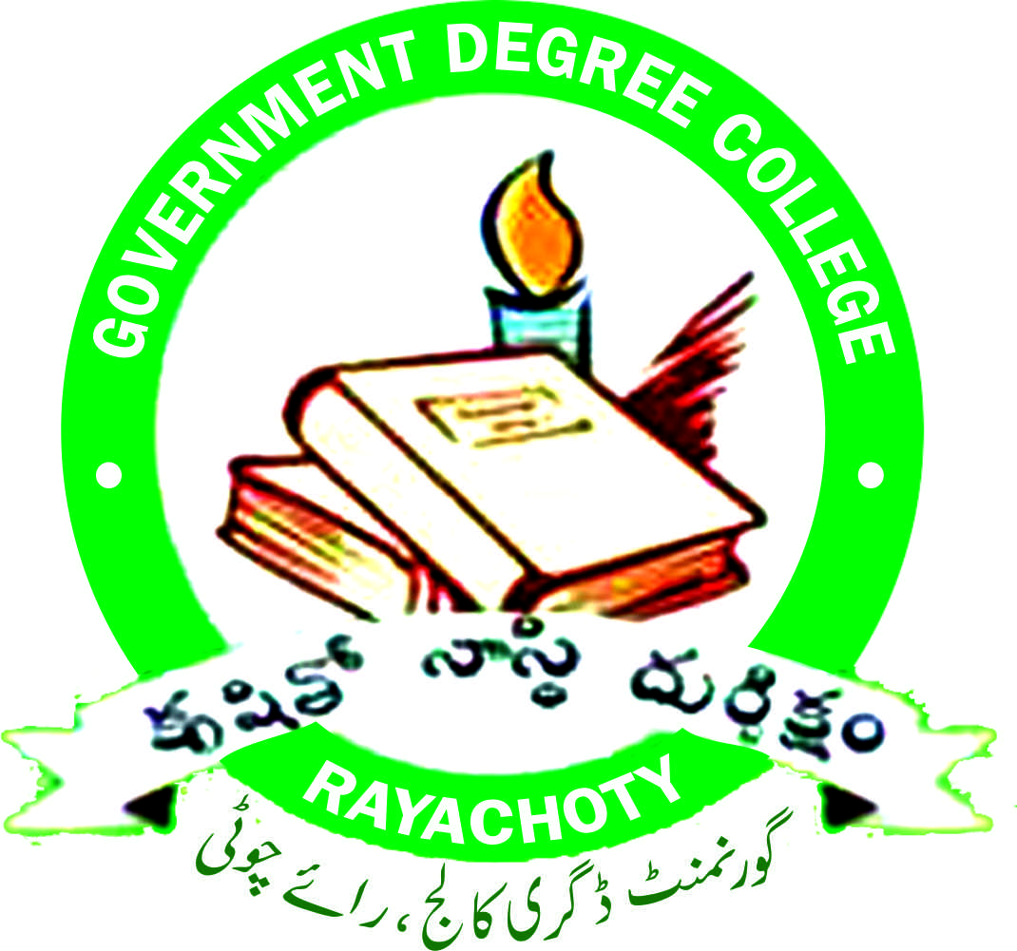
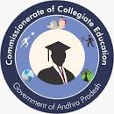
GOVERNMENT DEGREE COLLEGE, AR RAYACHOTY, YSR KADAPA DISTRICT, A.P.516269A
(Accredited with C grade by NAAC)
Dr. P. HARSHALTHA, M.Sc., M.Phil., Ph.D. E-Mail Id: rayachoti.jkc@gmail.com
PRINCIPAL Website: www.gdcrayachoty.ac.in
………………………………………………………………………………………………………………………………………………

7.1.2: The Institution has facilities and initiatives for

- Management of the various types of degradable and nondegradable waste

- Degradable Waste Management (Vemi Compost)
- Non-Degradable Waste Management (E-Waste Disposal)

- Degradable Waste Management (Vemi Compost)
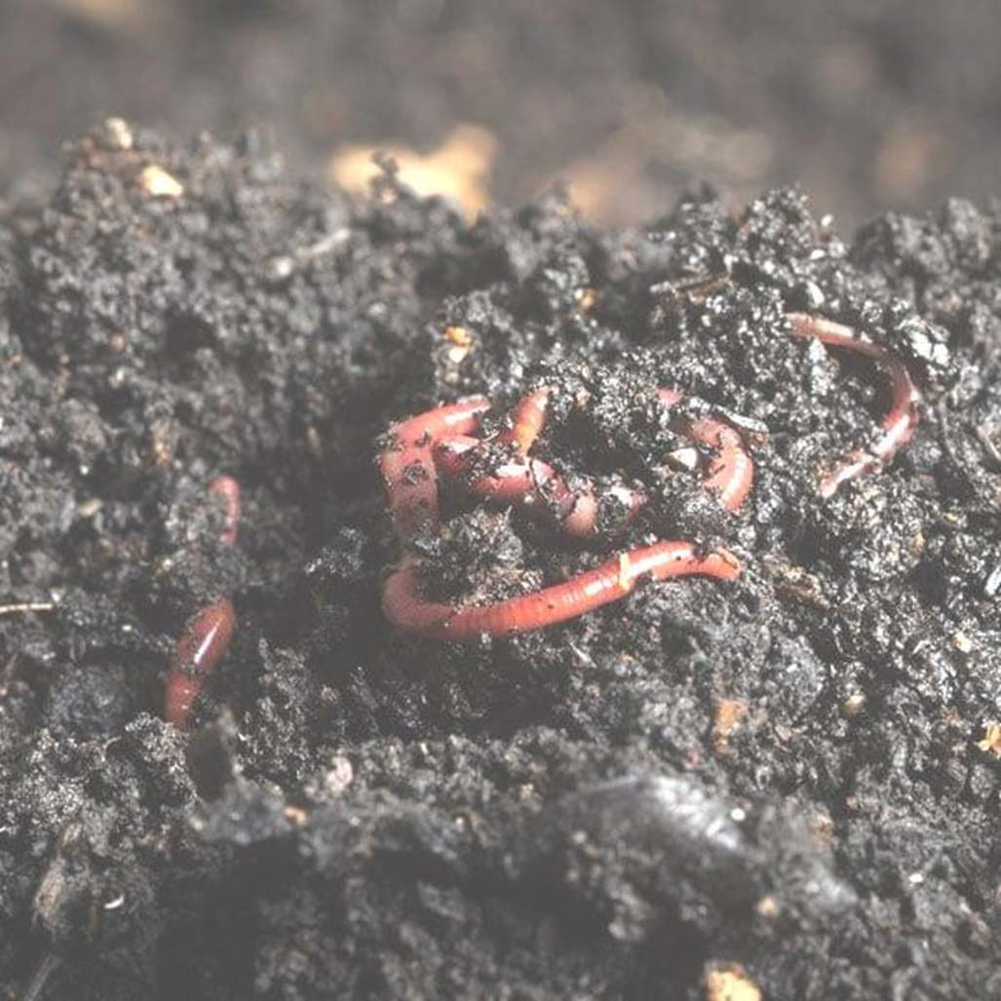

Introduction:

Vermicomposting is the process of using various species of worms, particularly red wigglers, white worms, and earthworms, to decompose organic waste and convert it into nutrient-rich compost.

This natural and eco-friendly method involves the breakdown of organic matter such as food scraps, vegetable peels, leaves, and other biodegradable materials through the worms' digestive system.

The end product, known as Verme cast or worm castings, is an excellent organic fertilizer that enhances soil structure, promotes microbial activity, and boosts plant growth.

OBJECTIVES :
- To utilize the wastes for the preparation of compost by using
Earthworms.
- To provide more knowledge to the students, in the field of Verme culture and vermicomposting.
- To enhance the skills of students by hands on experiment.
- To give knowledge about the importance of earthworms in the agriculture sector to the students.
- To provide an opportunity to the students, to gain knowledge about the maintenance of vermicomposting unit.

Purpose:
  - The basic purpose of Verme culture is to produce vermicomposting.
  - To supply vermicomposting to the local farmers at low cost.
  - To maintain clean and green in the campus by utilizing the waste leaves and other biodegradable materials.
  - Earthworms eat organic waste and break down into smaller molecules.
  - This allows microorganisms to quickly break down organic debris and create nutrients, allowing for rapid decomposition.
  - Soil microorganisms provide nutrients that make the soil more productive for plants.
  - Thus, earthworms assist in the environmentally friendly decomposition of organic waste.

Features of Vermicomposting:

1. Sustainable Waste Management: Vermicomposting provides an effective way to manage organic waste, reducing the volume of trash sent to landfills.

2. Nutrient-Rich Compost: Verme cast contains essential nutrients like nitrogen, phosphorus, and potassium, which are beneficial for plant health.

3. Eco-Friendly Process: Unlike chemical fertilizers, vermicomposting does not harm the environment and supports biodiversity in the soil.

4. Low Maintenance: The process requires minimal space and equipment, making it accessible for households, farmers, and urban gardeners.

Process:

1. Setting Up a Verme compost Bin: A simple bin with proper aeration and drainage is prepared and filled with bedding material such as shredded paper or leaves.

2. Adding Worms and Waste: Worms are introduced to the bin, along with food scraps and organic waste, which the worms feed on and decompose.

3. Monitoring the Environment: Worms thrive in a moist, dark environment with moderate temperatures, so regular monitoring is required to maintain the bin conditions.

4. Harvesting the Compost: After a few months, the Verme cast produced by the worms can be harvested and used in gardens or potted plants as a natural fertilizer.

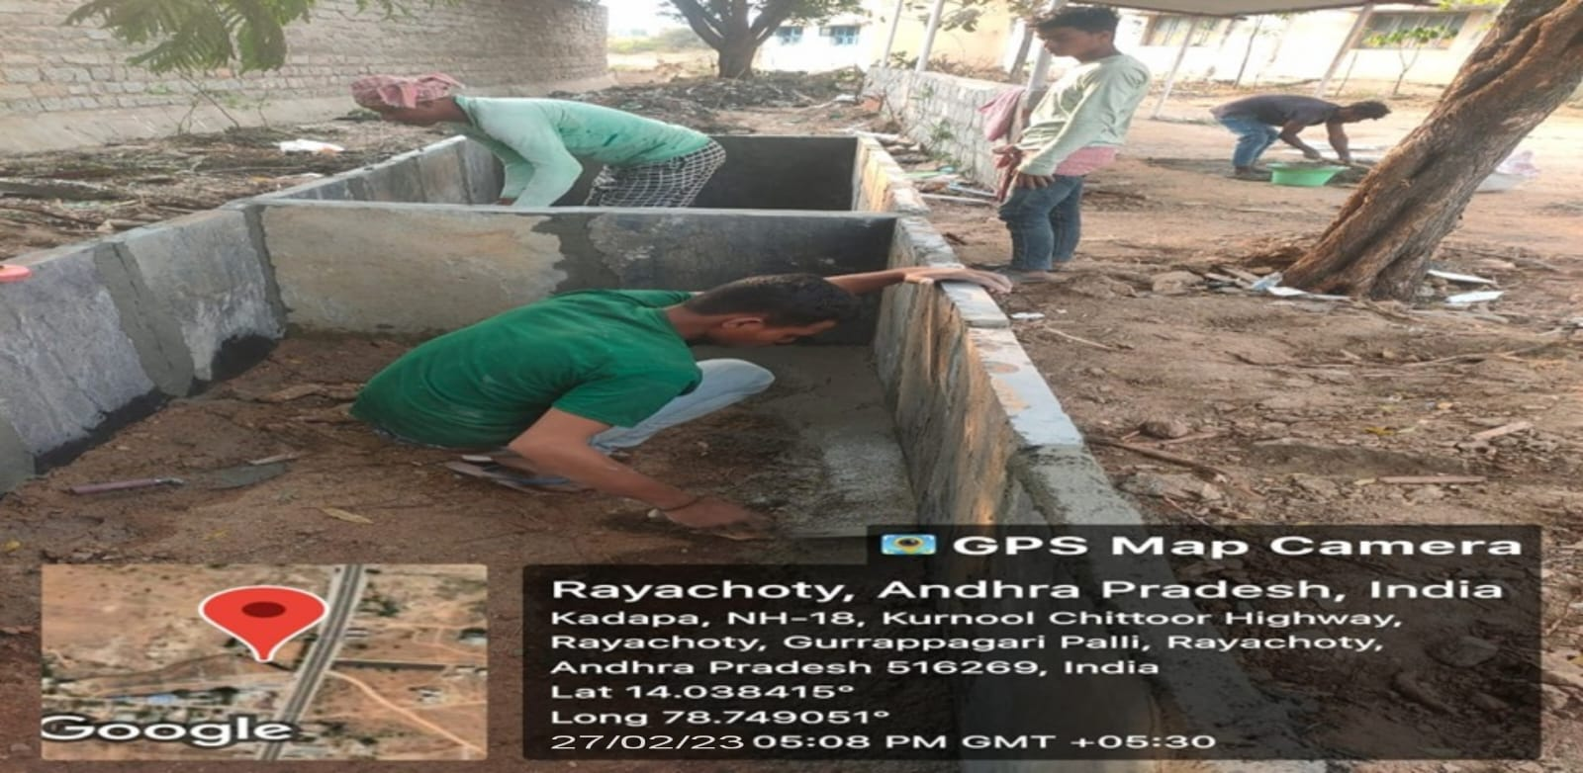
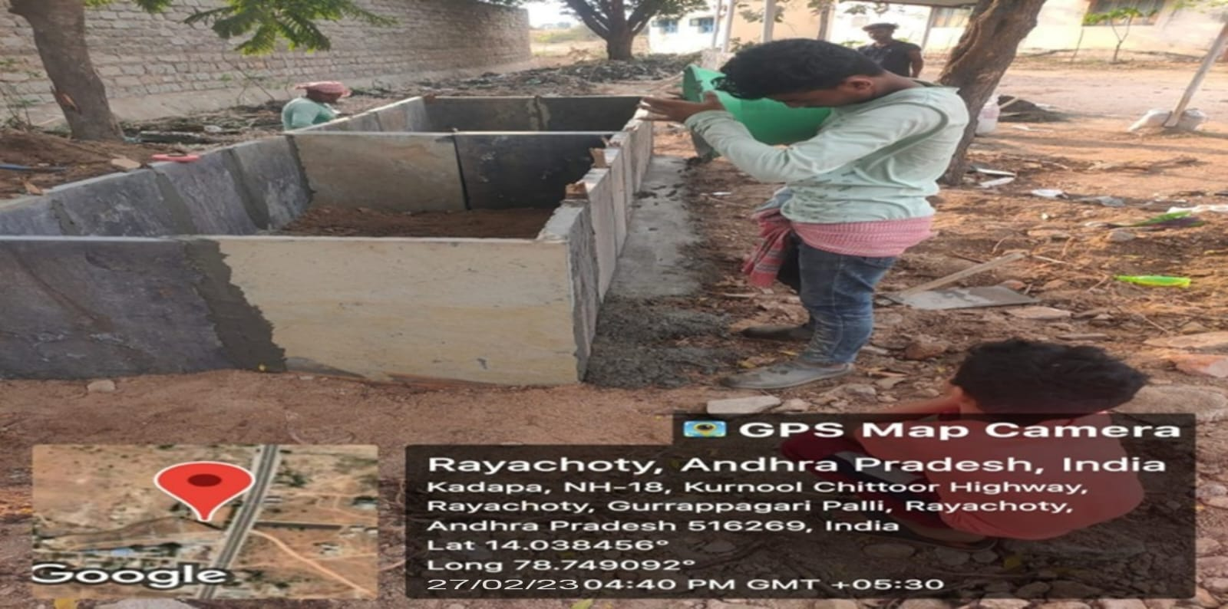
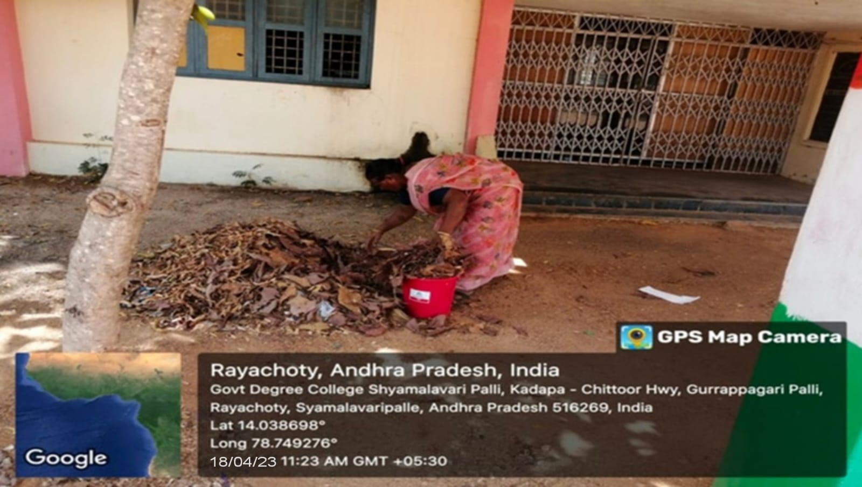
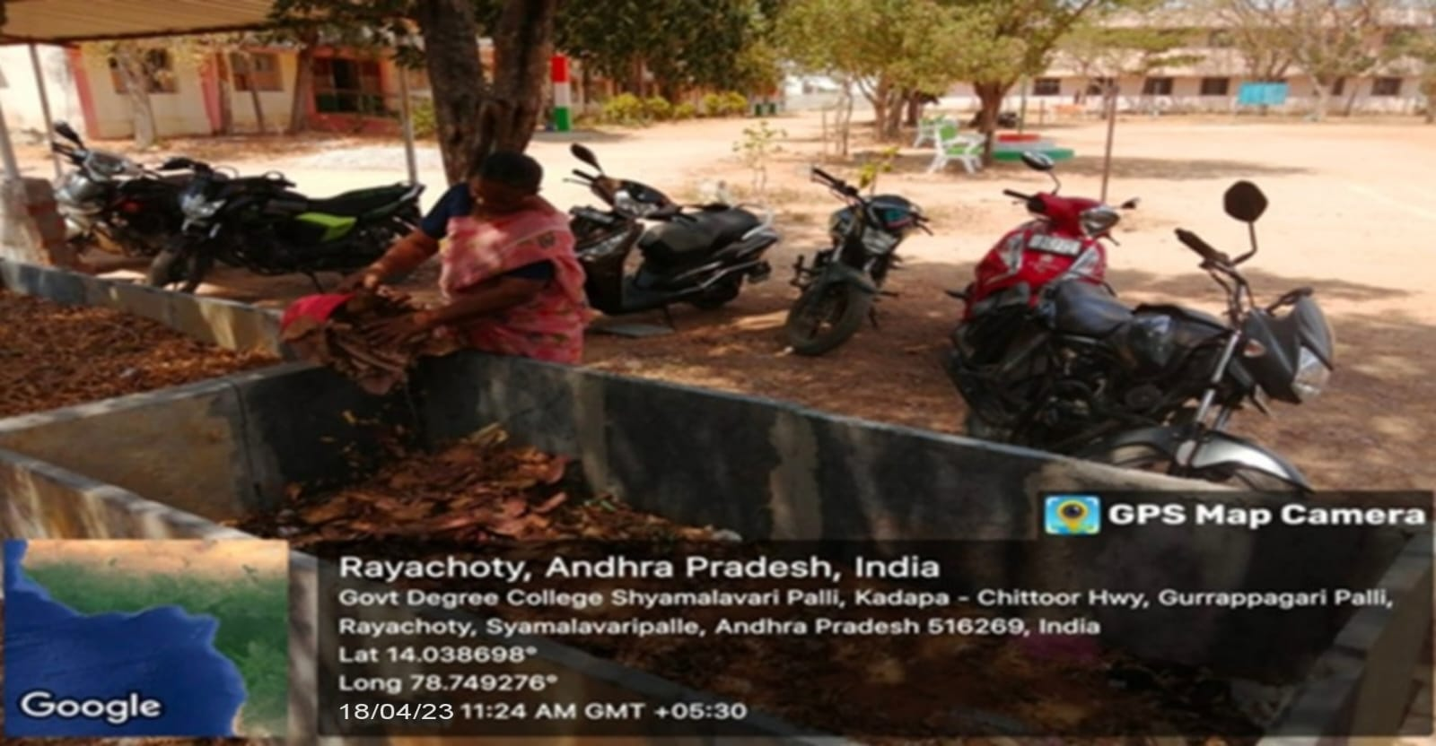

- Non-Degradable Waste Management (E-Waste Disposal)

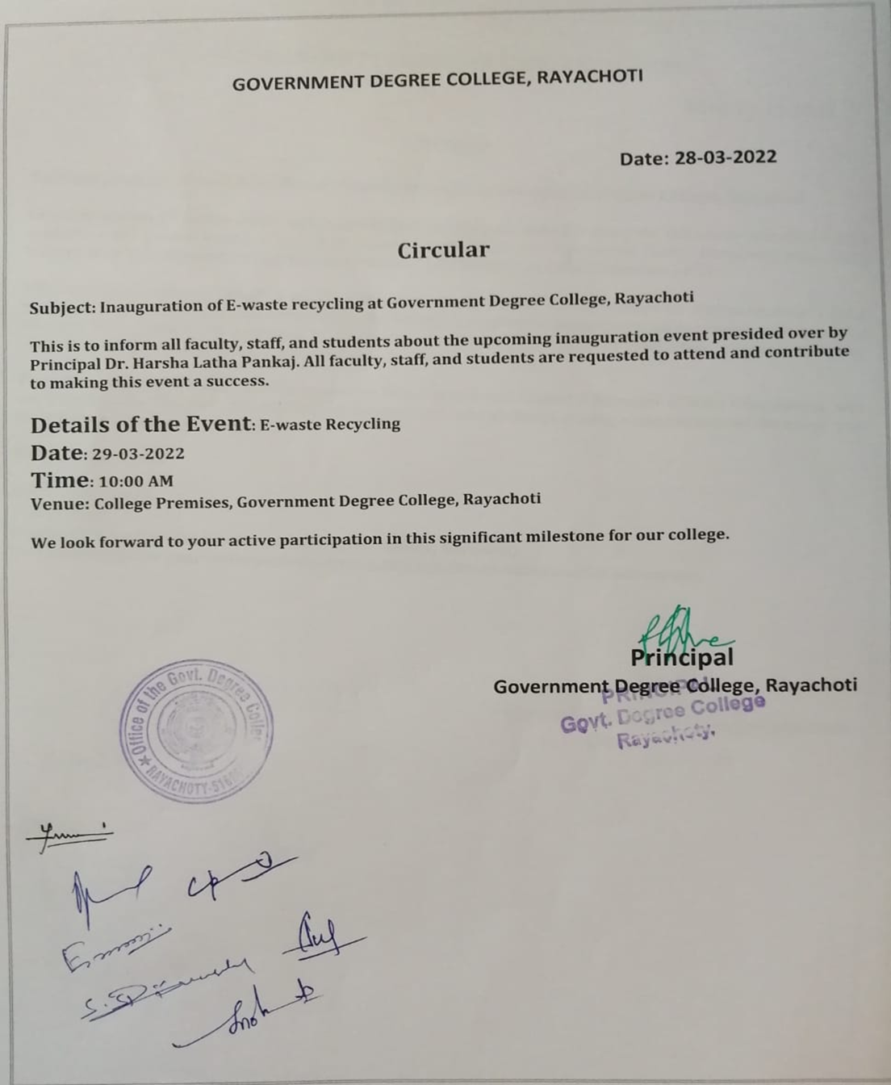

E-WASTE MANAGEMENT
Vision:
To foster an eco-friendly and sustainable campus environment by promoting responsible e-waste management practices, minimizing environmental impact, and raising awareness among students, faculty, and the community on the importance of e-waste recycling and sustainability.

Mission:
To implement efficient e-waste management practices that not only reduce the harmful effects of electronic waste on the environment but also educate and engage the college community in sustainable e-waste disposal and recycling efforts, in alignment with environmental regulations and ethical standards.

Objectives:

1. Reduce E-Waste Generation:
-To promote the use of durable, eco-friendly electronics.
-To encourage repair, reuse, and responsible consumption of electronic devices to minimize waste.

2. Proper Disposal and Recycling:
-To establish a systematic and safe e-waste collection and recycling program on campus.
-To collaborate with authorized e-waste recyclers for the safe and environmentally sound disposal of electronic waste.

3. Awareness and Education:
-To organize seminars, workshops, and campaigns to educate students and staff about the environmental hazards of improper e-waste disposal.
- To integrate topics of e-waste management and sustainability into academic courses and extracurricular activities.
4. Compliance with Regulations:
- To ensure compliance with national and international e-waste management laws and regulations.
-To regularly monitor and audit e-waste management practices to ensure continuous improvement and adherence to environmental standards.

5. Community Engagement:
-To extend e-waste awareness campaigns to the local community to promote proper disposal methods beyond the campus.
-To Host regular e-waste collection drives that are accessible to both the college and the surrounding community.

This framework will guide the college in creating an environmentally conscious culture while maintaining compliance with NAAC and environmental regulations.

